Sharon Keating Memorial Scholarship
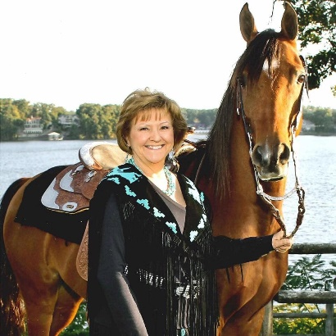
Sharon Keating loved sharing her Arabians; she was an avid Arabian horse lover, breeder of National Champions, and loyal friend. Over the years she encouraged friends to show her Arabians in local fun shows, Class A, Regional, and even National shows. Sharon could often be found on the rail cheering for her friends when they showed their horses, or hers. Sharon was also a founding member and Vice President of the Central States Arabian Horse Association Club.

In July 2021, Sharon lost her battle with cancer after a long fight. To honor her love of the Arabian breed and generosity in sharing her Arabians, several members of the Central States Arabian Horse Association created and began the funding for the Sharon Keating Memorial Scholarship.

The goal of the Sharon Keating Memorial Scholarship is to provide monetary assistance to newcomers who want to show an Arabian or Half-Arabian horse. Our objective is to provide one new person with the opportunity to show an Arabian at a “Class A” show through a $250 scholarship to cover all or part of the cost of stall, entry fees, class fees, etc.

Scholarship crieria:
- Applicant must be new to showing horses, preferance given to those who have never shown before.

- Applicant must be a member in good standing of the Central States Arabian Horse Association (AHA Club #11226).

- All disciplines are encouraged to apply.

- All age divisions are eligible to apply.

The Sharon Keating Memorial Scholarship will be awarded by April 15, and may be used at any Region 11 “Class A” show during the year. The scholarship recipient will need to designate which show they plan to attend, and the $250 scholarship will be paid directly to the designated show.

Please enclose the following for a complete application:
- Completed application form saved as a Word or PDF document.
- Essay answering questions posed at the end of the application saved as a Word or PDF document.
- One (1) letter of recommendation (not from a relative).
- Photo (optional)

Email the above information to: Michelle@PerspectiveFarms.com by April 1. Applicants will receive an email confirmation that their application has been received.

Thank you for applying!

Central States AHA Scholarship Committee
Basic Information

First Name:

Last Name:

City/State:

Phone Number:

Email:

Showing Information

Barn Affiliation (if any):

Trainer Name:

Trainer Phone Number:

Applicant Age Division:

Discipline(s) Competing In:

“Class A” Show Planning to Attend:

References (not a relative, will be contacted by the CSAHA Scholarship Committee)

Reference #1 Name:

Email:

Relationship:

Reference #2 Name:

Email:

Relationship:

Essay Questions (Answers may be combined, please use a separate page)

Please tell us about yourself and why you should be considered for the Sharon Keating Memorial Scholarship.

Describe your involvement with horses. Why did you choose Arabians? What makes the Arabian horse special to you?

Completed application must be returned by April 1.

